EpiData Analysis
- a short overview of

EpiData Analysis is a program for data analysis and data management.

Use EpiData analysis when you want to do basic descriptive statistical analyses, modifications or tabulation of data. Extended analysis such as statistical modelling can be done with other software such as Stata, R etc.

EpiData Analysis is based on the same principles as EpiData Entry. If you properly define, document and verify data with EpiData Entry, the definitions are also available in EpiData Analysis. E.g. specified legal values with attached text labels(1 = No 2= Yes) or definitions of missing values. When reading data EpiData Analysis will do some control based on variable definitions, e.g. all dates are verified.

EpiData Analysis is suitable for small as well as rather large datasets. simple datasets like one questionnaire as well as datasets with many or branching dataforms.

The principle of EpiData is rooted in the simplicity of the dos program Epi Info v6, which has many users around the world. EpiData Analysis is used for: Basic descriptive Analysis of quantitive data, Defining and modifying data, Editing / correcting data already entered, Graphing Data, Asserting that the data are consistent across variables and printing or listing data for documentation of error-checking and error-tracking.

Registration
All users are encouraged to registrate by using the form on www.epidata.dk . By registration you will receive information on updates and help us in deciding how to proceed development - and to persuade others to add funding for the development.

Limits and specification
No limit on number of observations. (tested with >100.000). Specification of the data file structure must fit within 999 lines of text. EpiData comes as a few files and only a few extra files are added to accomplish saving of graph files. Options are saved in an ini file. EpiData Analysis is freeware.

Works on Windows 95/98/NT/Professional/2000/XP and Machintosh with RealPc emulator. Tested on more than ten Linux variants based on WINE – some problems can show up.

Downloading and installing Download from www.epidata.dk and follow the instructions when you run the installation file. EpiData Analysis will not interfere with the setup of your computer. EpiData consists of one program file and a number of help files in html or pdf format. The program as such cannot be sold for money or service value. It is absolutely free. All translated versions must ALSO be supplied as free. There can be NO charge taken by a web site for downloading of EpiData.

For use of EpiData Entry and EpiData Analysis in courses and routine field work see end of document.

Flow Sheet of working with Analysis

Keep a COPY of data in memory

Read a data file
(REC, DBF, CSV)
For REC files: Read variable labels in Rec File and category label and missing value definitions
in associated CHK file
Add new variables generate or define commands

Change contents of variables
let, recode
if ... then ...,

Change sorting
sort command
Modify data in memory

Save data to disk
Command savedata

Show results on the Screen

Copy of results written to disk. Default name EAOutput.htm

Close: logclose
”Next” Analysis command
Stop Analysis
quit or exit

A copy of all commands are saved as temp.pgm

1. Setup screen of EpiData:
Get the latest version from Http://www.epidata.dk and install in the language of your preference. The installation and retrieval is fast since the whole size of the programme is small (2.5Mb in total). Simply run the installation file and follow the instructions.

The EpiData Analysis screen has a “standard” windows layout with one menu line, a toolbar, an output window, a command prompt where you write commands, an output window, a statusbar and depending on user action also a data browser, an editor and smaller windows showing available commands, variables in current file and a history of previous commands.
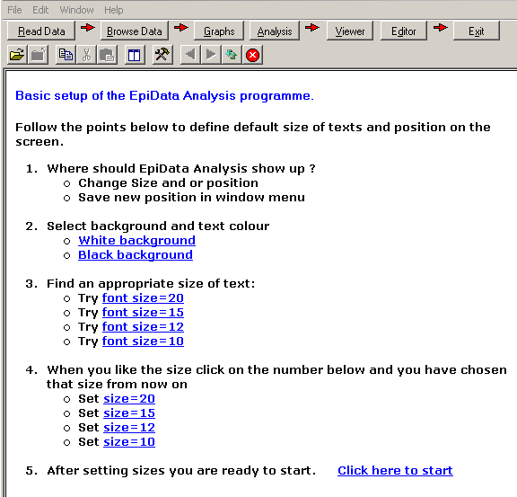

A. Start EpiData from either the programme group where you installed the programme or an icon.

B. First time you run EpiData Analysis the opening screen will be a setup screen where you decide overall size of programme, size for fonts you prefer etc. Just follow the numbers:

C. After clicking start and exit, the specifications are saved and the program exits. Restart to use the settings.

2. First start

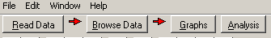
To give you an idea of how the programme works we will now try the “Process Toolbar”.

A copy of all output will be saved to the file EAoutput.htm. If you dislike this you can turn output off by choosing the “Close Output file” found under the “Viewer” button.

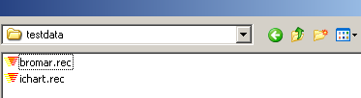
Press the “Read Data” button to the left on your screen and point your disk selector to where you installed the EpiData Analysis programme in the subfolder “testdata”.

Select “bromar.rec” (possibly shown only as “bromar”). by double clicking and notice the information in the output window, How many records and fields ? A copy of the data are read into memory.

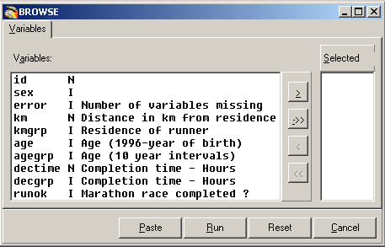
Browse data
Every time you open a data file it is good practice to view the data.

So on the process tool bar press the ”Browse” button, and you get this dialog box:
Select any number of variables or all by the ->> and choose ”Run”.

A data browser window is shown. Look at the data. Resize the window to cover right half of the screen and close it again.

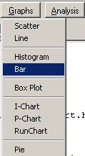
Showing a graph

Now we will try to see some results. Press the ”Graph” button and you see the small menu, where you choose ”Bar”

A dialog is shown to specify the graph further: On the dialog ”Choose X Variable”. Select Decgrp and press ”Run”

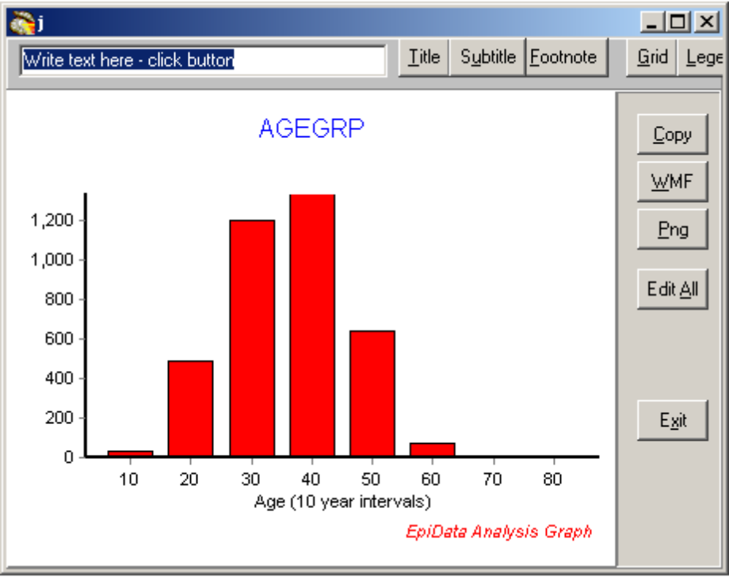
The graph is shown on a special form with some buttons.

Just press ”exit”

The graph will be added to the output window.

Try with kmgrp or decgrp variables and notice how the labels are shown at the buttom of the graph..
Showing a table of frequencies
On the ”process toolbar” try now analysis:
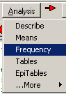
Select sex and agegrp variables in the dialog which is shown and press ”run”, after which you will see these tables:
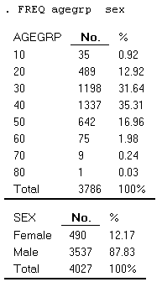

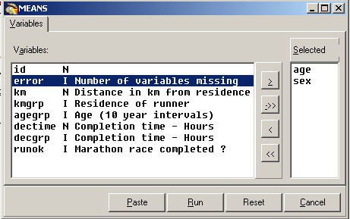

Showing means of age by time
Choose in Analysis instead ”Means” and ”run”. Note that age must be the top variable.

Are males or females on average the youngest ?

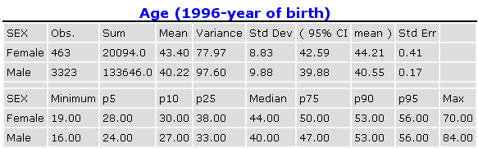
3. Which elements are on the screen ?
You have now acquainted your self with the programme and working with the process toolbar. On this page you see a complete picture.

To see a picture like this: Start EpiData Analysis, read a datafile into memory and press function keys F2 (commands), F3 (variables) and F7 (history).
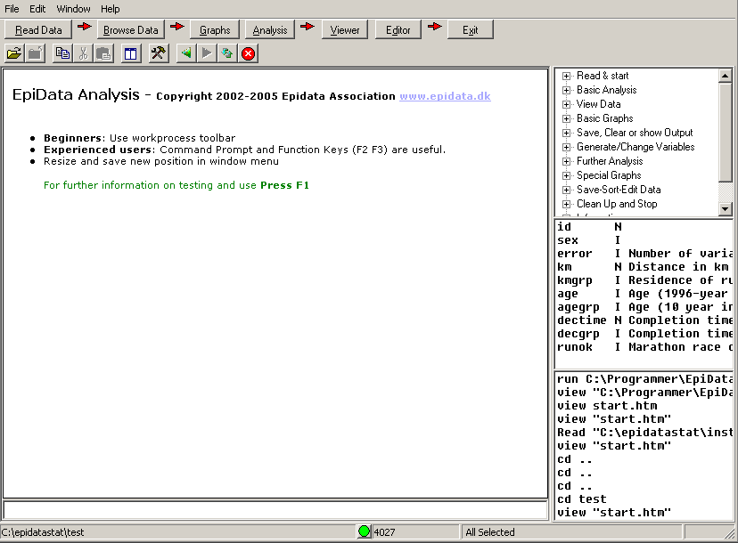
Change Folder
Main menu
work process Toolbar
Standard toolbar
Statusbar
Output window
Output browser control
Main menu
work process Toolbar
Standard toolbar
Commands (F2)
Variables (F3)
History (F7)
Statusbar
Command Prompt (F4)
Results window
(Viewer)
Viewer control
Editor (F5)
Browse data (F6 )

To get acquainted with the windows try the following:
1. Switch the extra windows on the right on and off a few times: Press keys: F2, F3 or F7
2. Resize the program by dragging in sides or the separator between output window (viewer) and right side parts.
3. Save current position in window menu. ”Save Window Position”
4. Try to change folder by clicking on the lower left side of the statusbar.
5. Try the editor. From within you can run commands or save pgm files for future use.
6. Try the help menu. If you are connected to internet you can activate ”Check Version” part which will compare your version with the most updated on on www.epidata.dk

Further introduction and support
Try the programme as it is and experience how you can soon get into more commands or features. If you press F1 an overview of help files is shown and if you press find (Ctrl+F) you can soon see how to get further explanations.

Further Sources for support:
1..Read the help files (press F1) or write a command in command prompt and press F1
2. Search the epidata-list for a solution or to ask a question.
The list is available at

http://lists.umanitoba.ca/mailman/listinfo/epidata-list

If you find errors or bugs when using the program or have suggestions for improval please discuss with the EpiData-list available at http://lists.umanitoba.ca/mailman/listinfo/epidata-list

Suggested citation of EpiData Analysis program:

General reference for EpiData Analysis and EpiData DataEntry is:
Lauritsen JM. (Editor) EpiData Data Entry, Data Management and basic Statistical Analysis System. Odense Denmark, EpiData Association, 2000-2006. (Available from Http://www.epidata.dk).
EpiData Analysis is based on a number of individual contributions:
JM.Lauritsen (2001-) Coordinator. Design, interface, implementation, documentation, testdesign, programming.
Mahmud S. Design and Implementation of core parsing principles and modules for EpiData Analysis. 2003 (source code).
M.Bruus(2004-). Programming and specification. Programming: T.Christiansen(2004-)
Lauritsen JM. Output design definition in EpiData Analysis. EpiData Association, Odense Denmark, 2005. (Contributor J. Hockin) Http:\\www.epidata.dk\analysisinfo\html output definition.htm
Development and Specification of SPC modules in collaboration with Gruk, Norway: V.Høgli (2004), B. Nyen (2004-)

Funding and acknowledgements.
An updated list of attained funding is available at Http://www.epidata.dk/funding.htm. Further credits and acknowledgements at: Http://www.epidata.dk/credit.htm . International translations made to several languages, see Http://www.epidata.dk For donations to further development see help file or send an e-mail to info@epidata.dk. Isolated parts of source code based on freeware and shareware components. Please consult credit pages.

Disclaimer
The EpiData Analysis software program was developed and tested to ensure fail-safe analysis and documentation of data. We made every possible effort in producing a fail-safe program, but cannot in any circumstance be held responsible for errors, loss of data, work time or other losses incurred by or in relation to the program. A copy of test documentation and procedures available on request. It is always good practice to compare different types of software until you are familiar with a given type of software.

Use in courses or routine field work:
Course materials based on contents of Http://www.epidata.dk cannot be sold for money value without agreements with the EpiData Association. The programme cannot be part of course materials which are sold for money value. Costs for course participation can be paid separately. Organisations outside low-income countries using EpiData as a base for courses or routine field use are expected to assist with funding or support for further development and maintenance of software. Contact info@epidata.dk for clarification. Do always inform of the possibility for free downloading from www.epidata.dk

If you are on a slow modem line you might not agree to “fast”, but in comparison to many programmes this is a small size
If you are not familiar with installing programmes get help from someone experienced. In some networks you might have to ask a supervisor first. However you can always install on a “temp” folder for yourself as a user.
If you want to reselect later then view the startepi.htm file

